|  |  |  |  |  |  |
| --- | --- | --- | --- | --- | --- |
| Date | 28-Nov-22 | | | Tester Name | Jessie Liu |
| Environment | Select Environment | | | Login used |  |
| Operating System | Select OS | Version: | Update: | | |
| Software Used | Select Software | Version: | Update: | | |
| Select Software | Version: | Update: | | |
| Release version |  | | | | |
| Title | Add a new contact, update a contact, and remove a contact | | | | |
| Test Type | Regression | | | | |
| Test Scenario |  | | | | |
|  |  | | | | |
| Expected Results |  | | | | |
| Pass/Fail | Pass | | | JIRA# | N/A |

Describe your steps with screenshots:

1. Select an employer

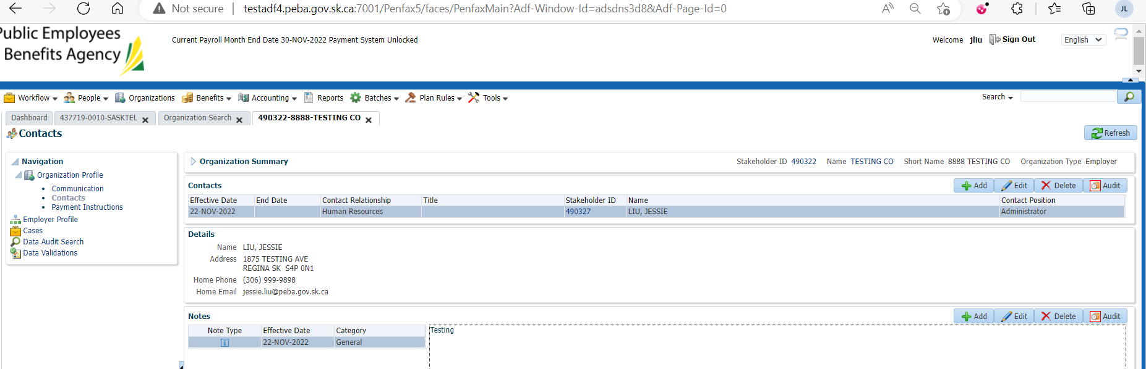

1. Add a new contact

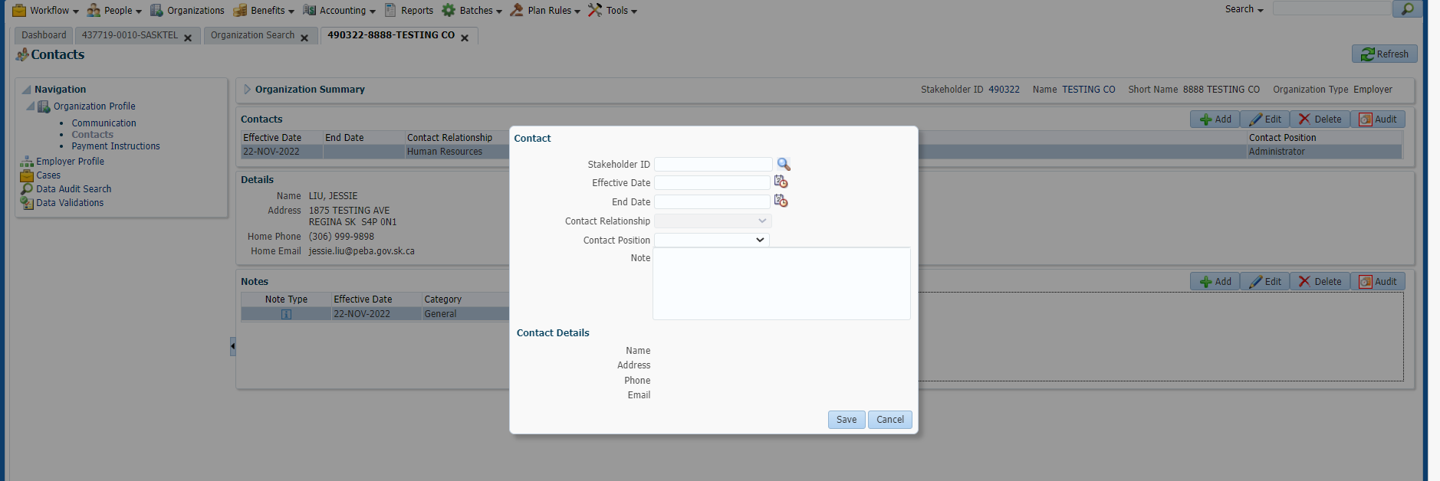

Click search

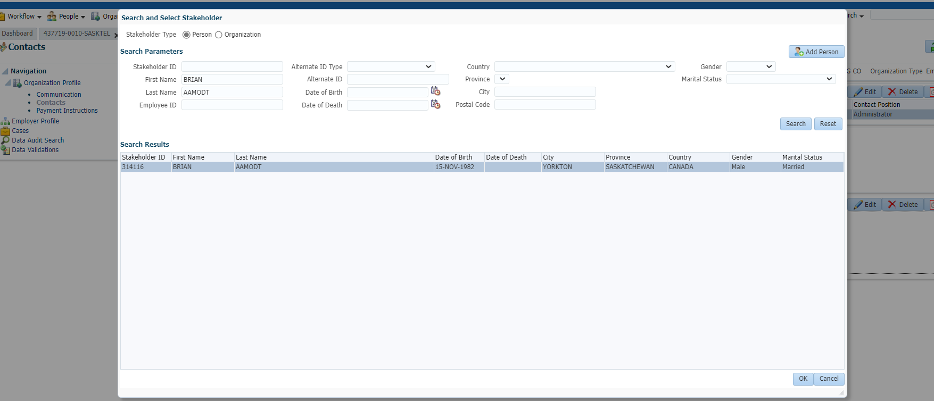

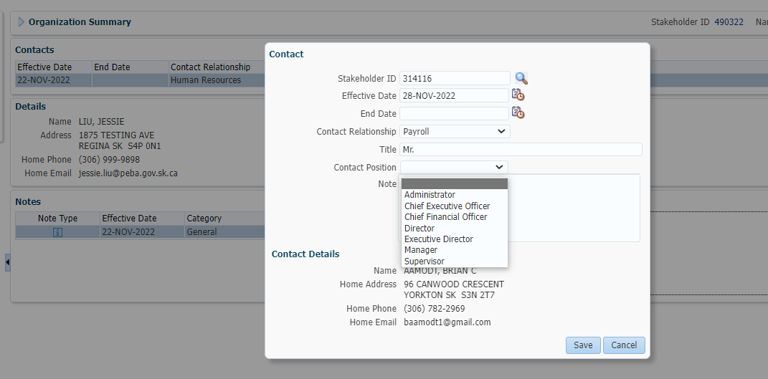

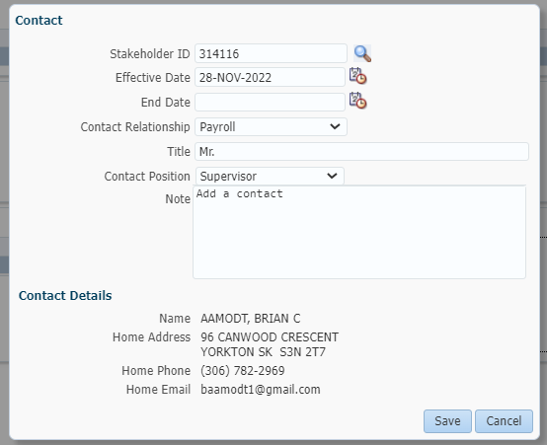

Contact is added

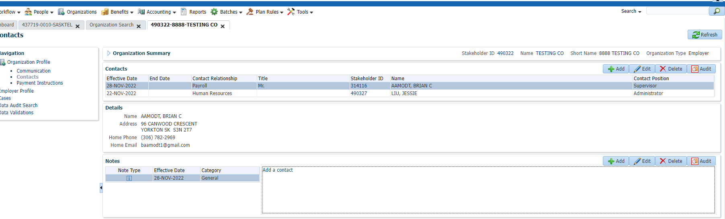

1. Update a contact

Select a contact and click Edit button

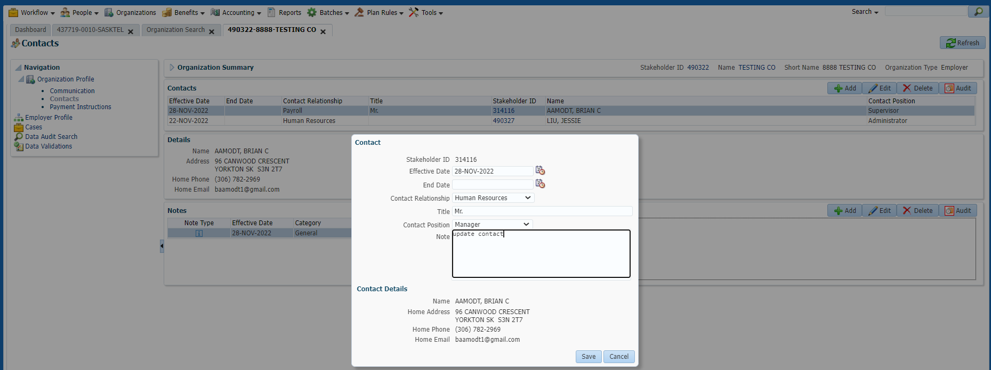

Contact is updated

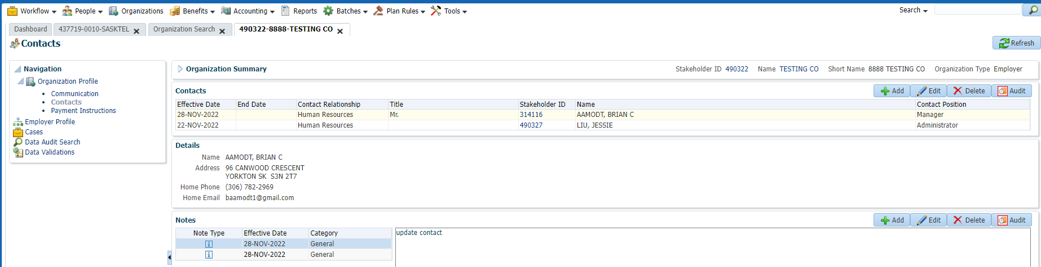

1. Remove a contact

Select a contact, and click Delete button

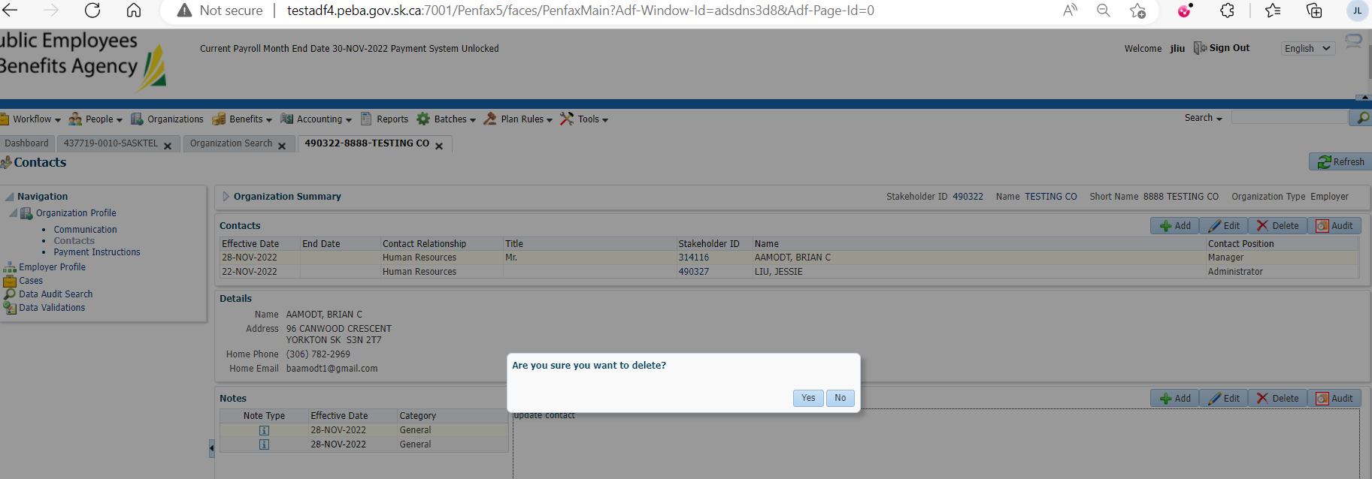

Contact is removed

